Minikube and Docker setup for deploying and running spring boot and react application

Setting up maven:

Download maven from location (<https://maven.apache.org/download.cgi>)

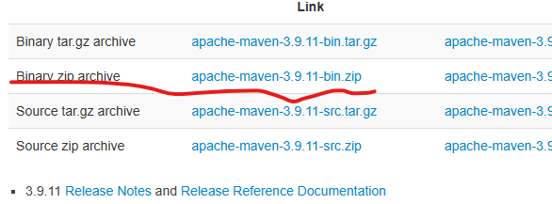

Extract maven to certain location and add the location to environment variables:

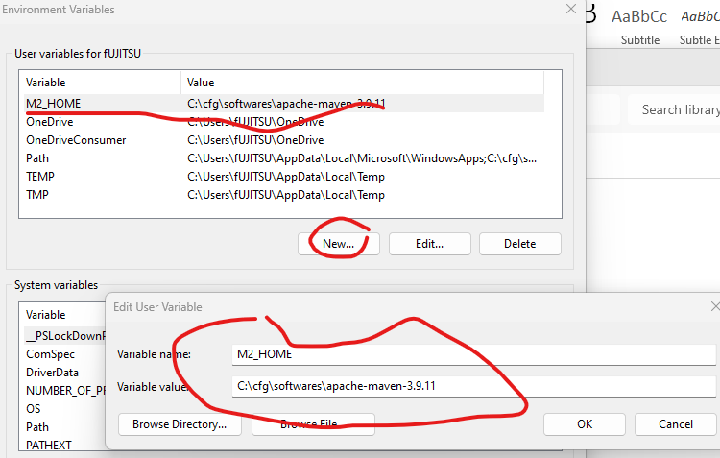

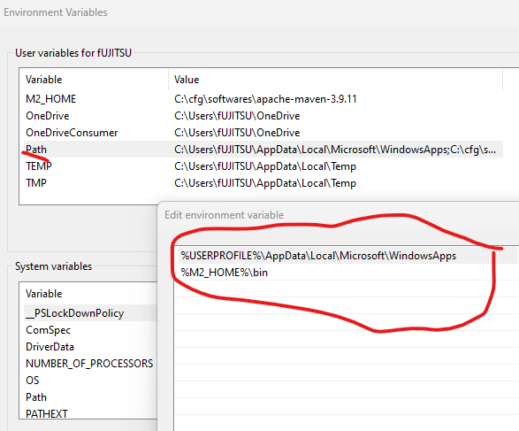

Enable WSL: controlpanel🡪 uninstall software 🡪Trun windows features on or off  
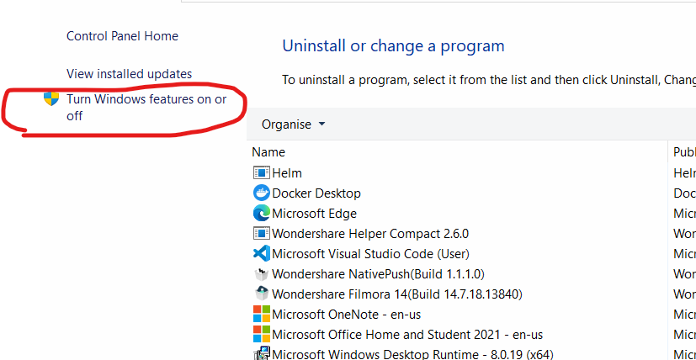 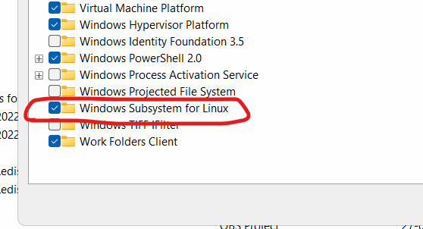

Softwares needed: install the following softwares  
Docker Desktop (https://docs.docker.com/desktop/setup/install/windows-install/)

Minikube (https://minikube.sigs.k8s.io/docs/start/?arch=%2Fwindows%2Fx86-64%2Fstable%2F.exe+download)

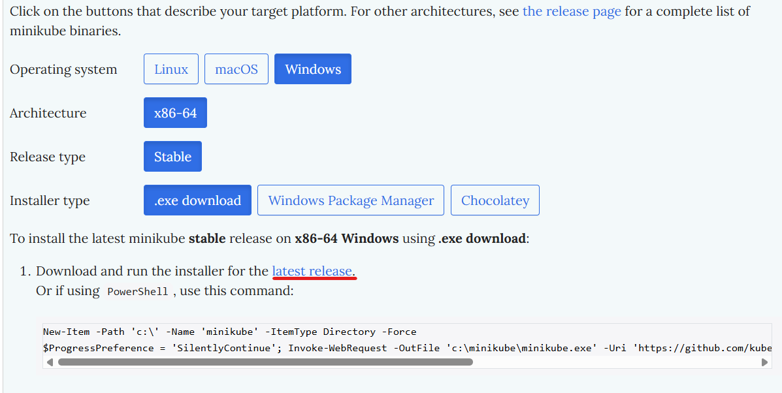

First install docker desktop, then minikube

After installing docker desktop login with your personal emaild.

Once installing docker desktop and minikube check the following commands

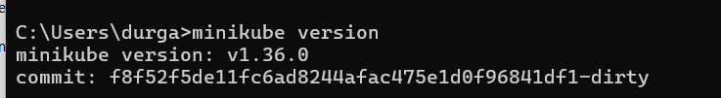

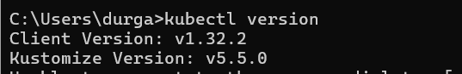

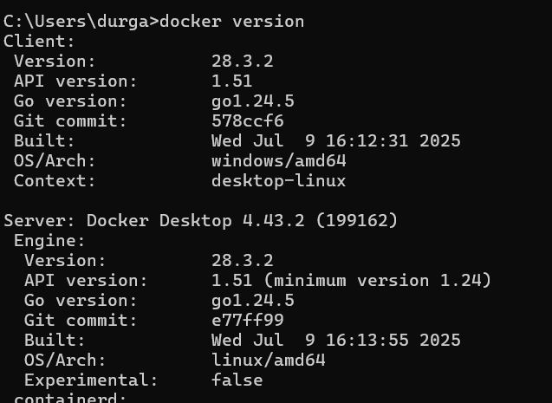

Create dockerhub repository 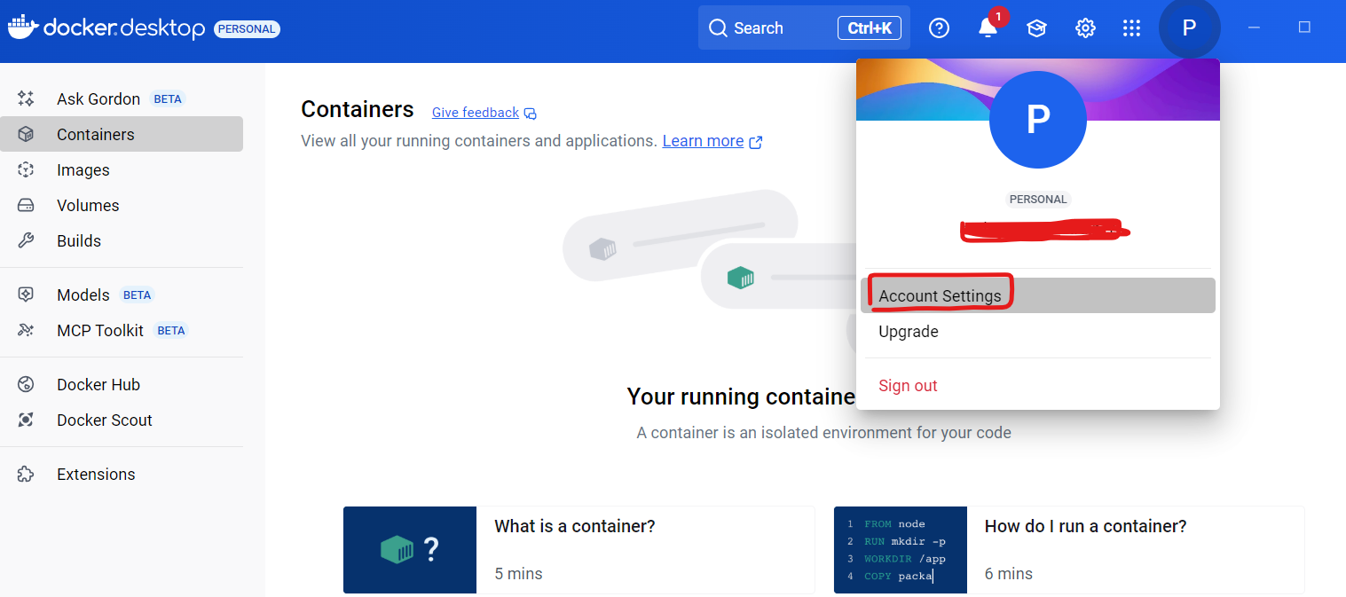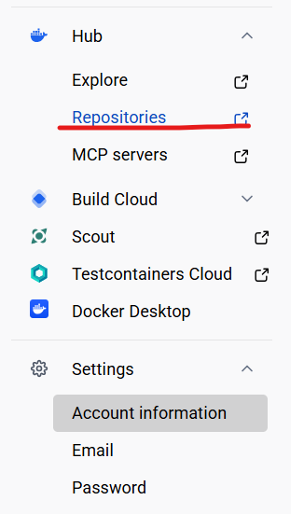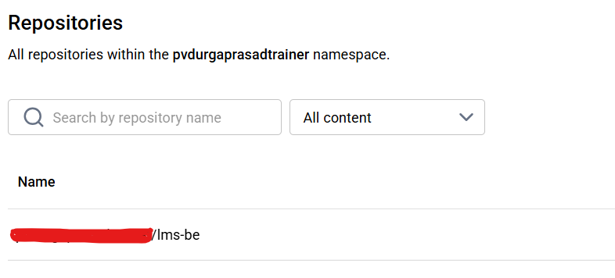

Build docker images for backend and frontend

docker build -t my-hub-repo/lms-be:1.0 .

docker push my-hub-repo/lms-be:1.0

docker build -t my-hub-repo/lms-rct-app:1.0

docker push my-hub-repo/lms-rct-app:1.0

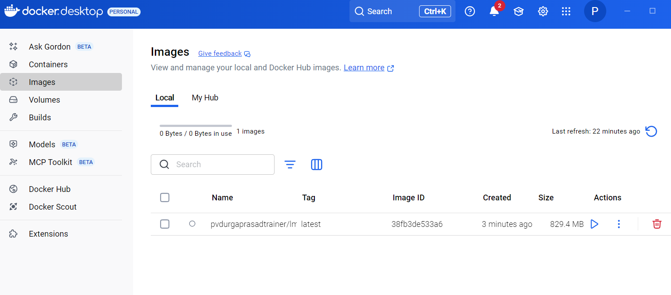

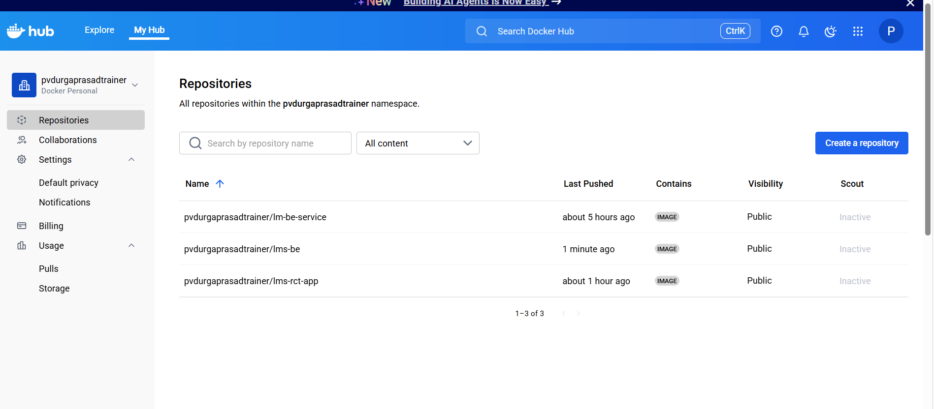

Commands:

minikube start

minikube dashboard

minikube addons enable metrics-server

kubectl apply -f deployment-be.yaml

kubectl apply -f deployment-fe.yaml

kubectl apply -f service-be.yaml

kubectl apply -f service-fe.yaml

kubectl get pods

kubectl delete pod <<pod-name>>

to expose hosts

minikube addons enable ingress

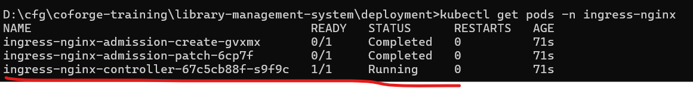

kubectl get deployment

NAME READY UP-TO-DATE AVAILABLE AGE

lms-be-deployment 1/1 1 1 14m

lms-rct-app-deployment 1/1 1 1 10m

kubectl get svc

kubectl port-forward svc/lms-be-svc 7070:7070

kubectl port-forward svc/lms-rct-app-svc 5173:5173

kubectl port-forward svc/ mariadb-headless 3306:3306

changes to backend service for connecting to mariadb:

download mariadb from https://mariadb.org/download/?t=mariadb&p=mariadb&r=12.0.2&os=windows&cpu=x86_64&pkg=msi&mirror=iitdelhi

<dependency>  
 <groupId>org.mariadb.jdbc</groupId>  
 <artifactId>mariadb-java-client</artifactId>  
 <scope>runtime</scope>  
</dependency>